Foundations@Waverley Long Term Plan 2023/24
Love Reading |  |  | Be Respectful |  |  | Communicate Effectively
 | Autumn 1 | Autumn 2 |  | Spring 1 | Spring 2 |  | Summer 1 | Summer 2
FS0  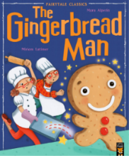  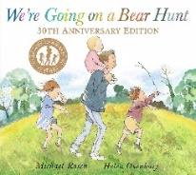  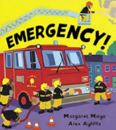  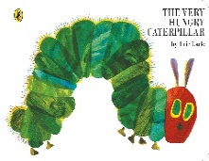 | Topic  Bear Necessities  Link to important people | Topic  World of Pure Imagination  Mini topic- Friendships |  | Topic  People Who Help Us  Mini topic- Emotions | Topic  It’s a Pirates Life For Me  Mini topic- Differences between people |  | Topic  Mad About Minibeasts  Link to materials | Topic  The Great Outdoors  Link to Weather & Outdoors
 | Curriculum Goal  To listen to other people’s talk with interest. | Curriculum Goal  To name friends they have made. |  | Curriculum Goal  To talk about different emotions and how they feel. | Curriculum Goal  To notice and ask questions about differences between people. |  | Curriculum Goal  To name, talk about and describe different Minibeasts. | Curriculum Goal  To explore and respond to different natural phenomenon.
 | WOW Moment  Teddy Bears Picnic | WOW Moment  Fancy Dress Day |  | WOW Moment  Visit to Role-play Centre | WOW Moment  Treasure Hunt |  | WOW Moment  Minibeast workshop | WOW Moment  Visit to Local Park
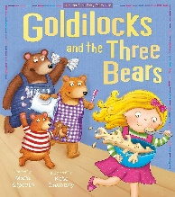  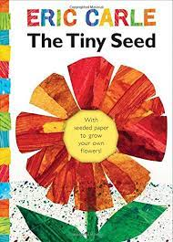  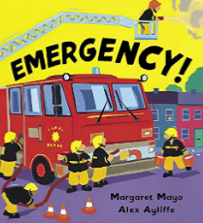  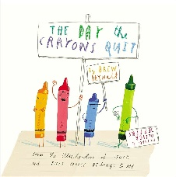  FS1 | Topic  Bear Necessities  Mini topic- Families | Topic  World of Pure Imagination  Link to materials and textures |  | Topic  People Who Help Us  Link to own life story and occupations | Topic  Somewhere Over the Rainbow  Mini topic – Emotions |  | Topic  Amazing Animals  link to animals from different  countries | Topic  The Great Outdoors  Link to plants and the environment  Mini topic – forces
 | Curriculum Goal  To talk about their family history and life story. | Curriculum Goal  To develop complex role-play/imaginary play stories. |  | Curriculum Goal  To show interest in different occupations. | Curriculum Goal  To create simple colour patterns |  | Curriculum Goal  To talk about animals and their habitats. | Curriculum Goal  To learn the life cycle of a plant.
 | WOW Moment  Teddy Bears Picnic | WOW Moment  Fancy Dress Day |  | WOW Moment  Visit to Role-play Centre | WOW Moment  Colour Party |  | WOW Moment  Minibeast Workshop | WOW Moment  Visit to Local Park
FS2  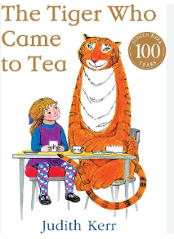  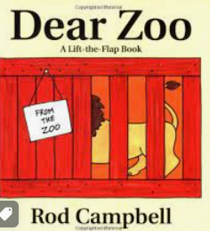  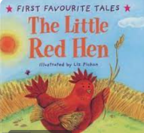 | 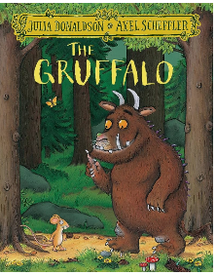  Topic  Marvellous Me and My Wonderful Community  link to families  and community | Topic  One Cosy Night  link to seasons |  | Topic  Once Upon a Time  link to maps | Topic  Once Upon a Time  link to materials |  | Topic  Animal Kingdom  link to environments and different places around the world | Topic  Animal Kingdom  mini topic – seaside past and present  mini topic – different seaside features  mini topic – how transport has changed over time
 | Curriculum Goal  To talk about and describe their immediately family and  community and people who are familiar to them. | Curriculum Goal  To explore the natural world around them and recognise the effect of different seasons. |  | Curriculum Goal  To compare and contrast Waverley to Fairy Tale land.  To compare and contrast characters from stories. | Curriculum Goal  To use our imaginations to invent creatures, places and stories. |  | Curriculum Goal  To compare and contrast animals from around the world. | Curriculum Goal  To learn about the life cycle of a butterfly.  To talk about how things have changed over time.
 | WOW Moment  Tea Party  Teddy Bears Picnic | WOW Moment  Autumn Walk  Gruffalo Crumble |  | WOW Moment  Baking Bread  Planting a bean  Library Service Visit | WOW Moment  Fairy Tale Workshop |  | WOW Moment  Visit a farm | WOW Moment  Visit to the library  Watching the Caterpillar Life Cycle
 | Workshop- Introduction to phonics | Creative Afternoon- Calendars crafts |  | Showcase- Retell a traditional tale | Creative Afternoon – Easter and Spring crafts |  | Showcase – Dear Zoo story and Animal dance  Extra Workshop – Fluency in Reading | Workshop- Year 1 Ready

